Appointment Booking

|  |  |
| --- | --- |
| Document Prepared By: | Arkam Abu Bakar |
| Document Reviewed By: | Fatima Afzaal / Saad Mirza |

Table of Contents

Booking Office Visit appointment as a new patient from novelHealth 3

Booking TM appointment from novelHealth 8

Booking Office Visit / TM appointment as a non-vendor provider from Calendar Module 12

Booking Office Visit / TM appointment as a Practice User from CureMD 10G 15

Collect Patient Demographics at Booking/Enable Insurance/Enable Insurance Eligibility bits in appointment booking flow 18

# Booking Office Visit appointment as a new patient from novelHealth

* Go to the URL <https://staging.novelhealth.ai/>.



* Select the "**Find a Top Doctor**" option from the Home screen.

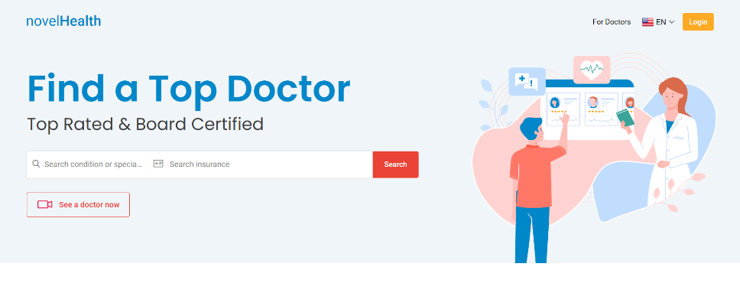

* **Search** **condition or specialty (Counselor)** in the search bar. **Search Insurance** from the available list or select the "**Self-Paying**" / "**Skip insurance**" option from the dropdown.

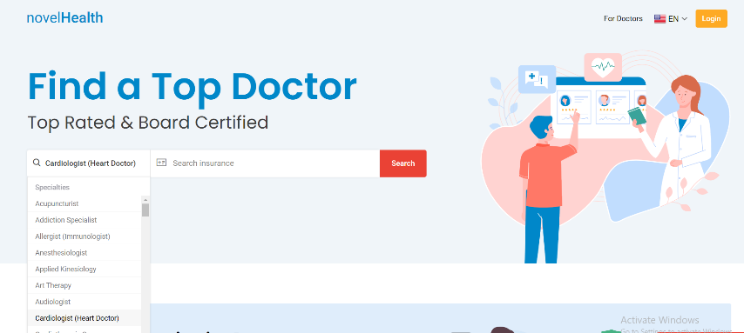

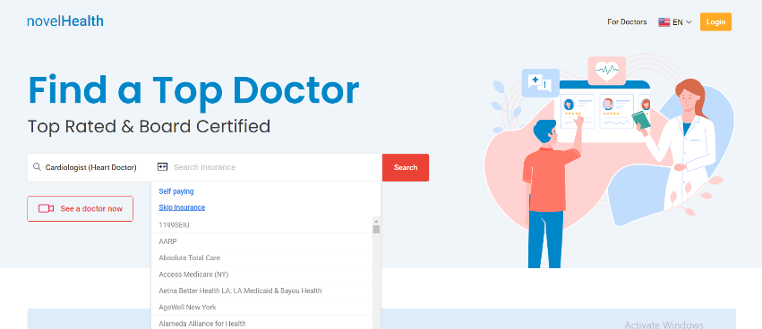

* On pressing the **Search** button. A list of providers will be visible to the patient.

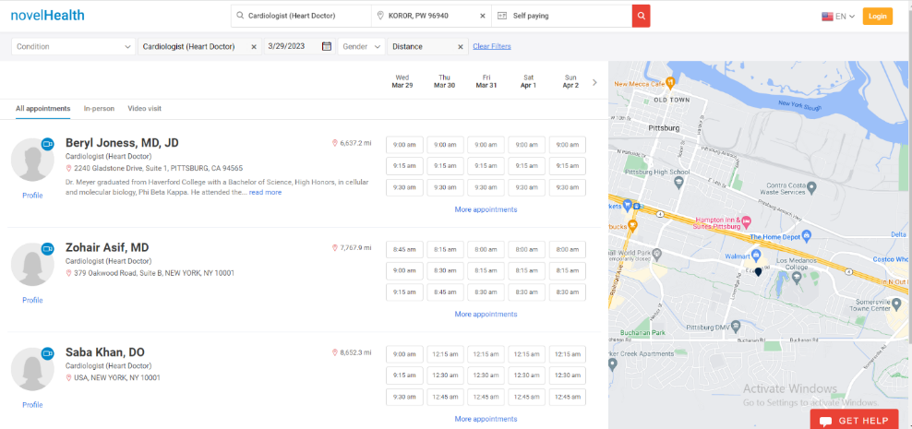

* Select any provider (doctor) of your choice. Select **Profile** to visit the profile of provider. Select **More appointments** to check available appointment slots.

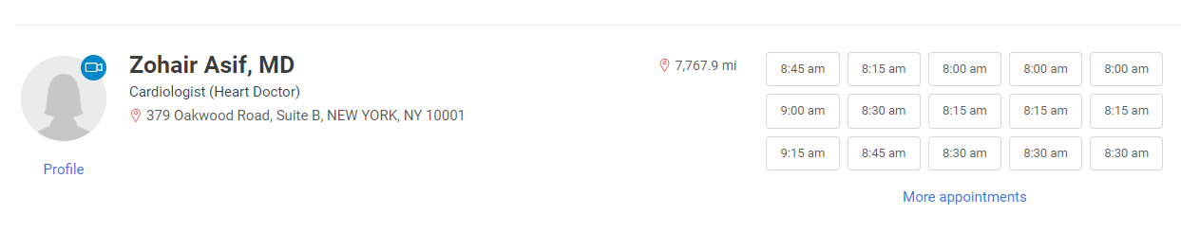

* Select any slot from the available slots. On selecting slot, patient will land on the **Log In page**.

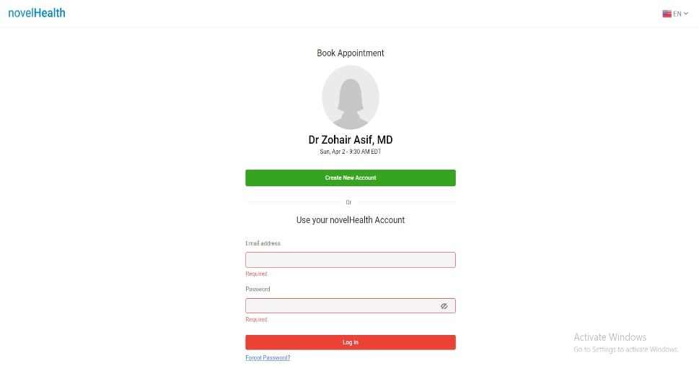

* Select "**Create New Account**" option. On selecting the "Create New Account" option, user will land on the **Sign-Up page**. Fill the information to create patient on the sign-up page and select the "**Save and Continue**" option.

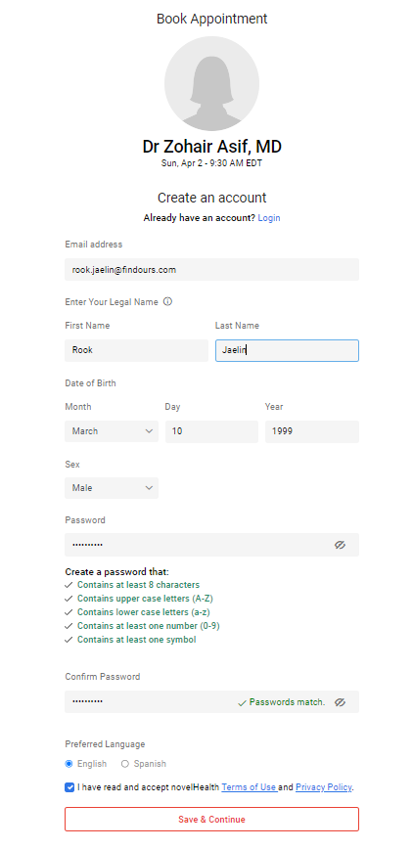

* On pressing save and continue button from sign-up page, patient will land on appointment booking page. Select “**Office visit**" as visit type and press the "**Book Appointment**" button.

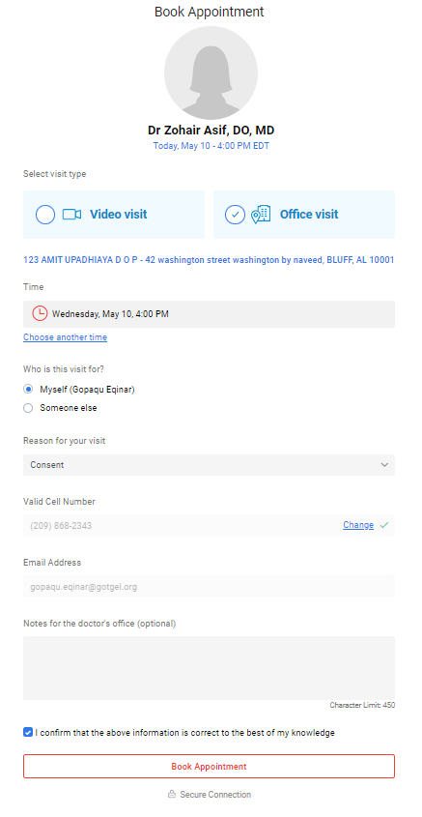

* A verification will send to patient’s provided Email Address and Cell Number when he/she is booking appointment for the first time. Enter verification code and select "**Verify**" option.

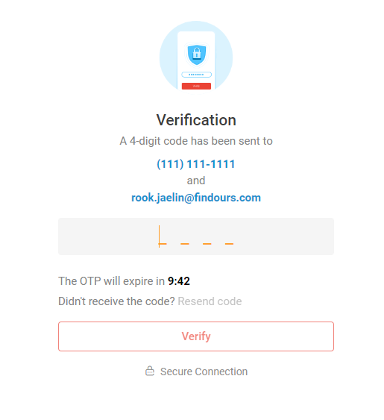

* On pressing the verify button from verification page, patient will land on Dashboard and appointment will get scheduled for the patient.

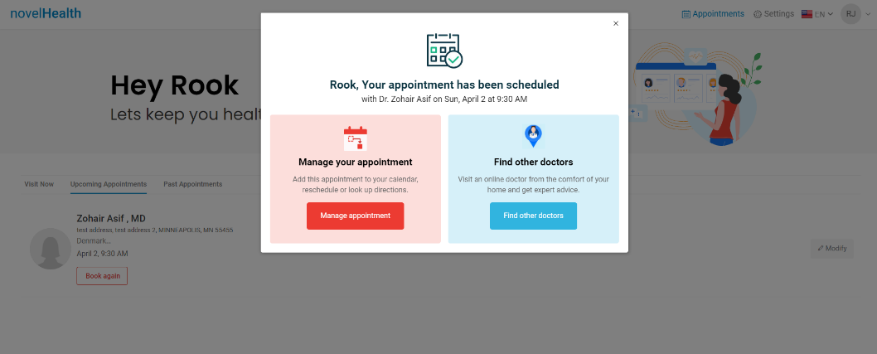

* Patient will receive Appointment confirmed email in his/her inbox.

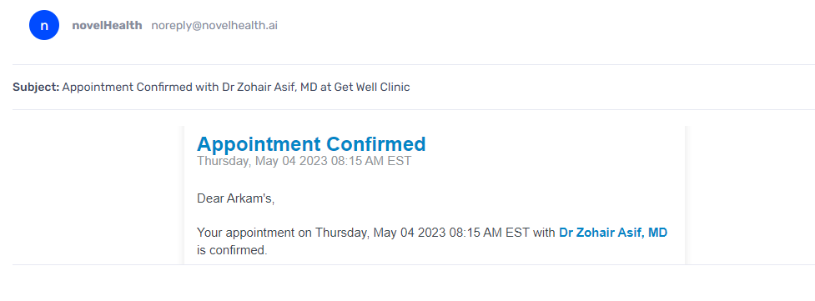

* The scheduled appointment will appear on patient’s dashboard.

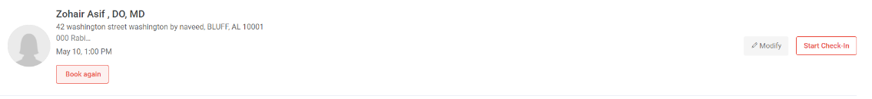

* Patient can **Reschedule/Cancel** the appointment by selecting "**Modify**".

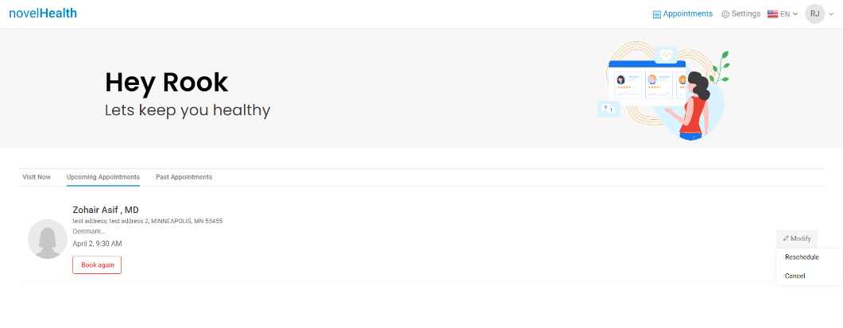

# Booking TM appointment from novelHealth

* Go to the URL <https://staging.novelhealth.ai/>.



* Select the "**Find a Top Doctor**" option from the Home screen.



* **Search** **condition or specialty (Counselor)** in the search bar. **Search Insurance** from the available list or select the "**Self-Paying**" / "**Skip insurance**" option from the dropdown.





* On pressing the **Search** button. A list of providers will be visible to the patient.



* Go to **Video visit** tab. Select any provider (doctor) of your choice. Select **Profile** to visit the profile of provider.

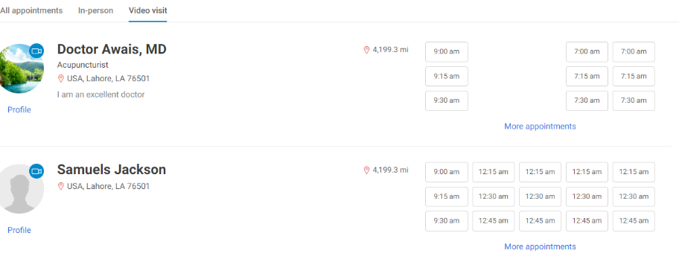



* Select any slot from the available slots on Provider profile page.

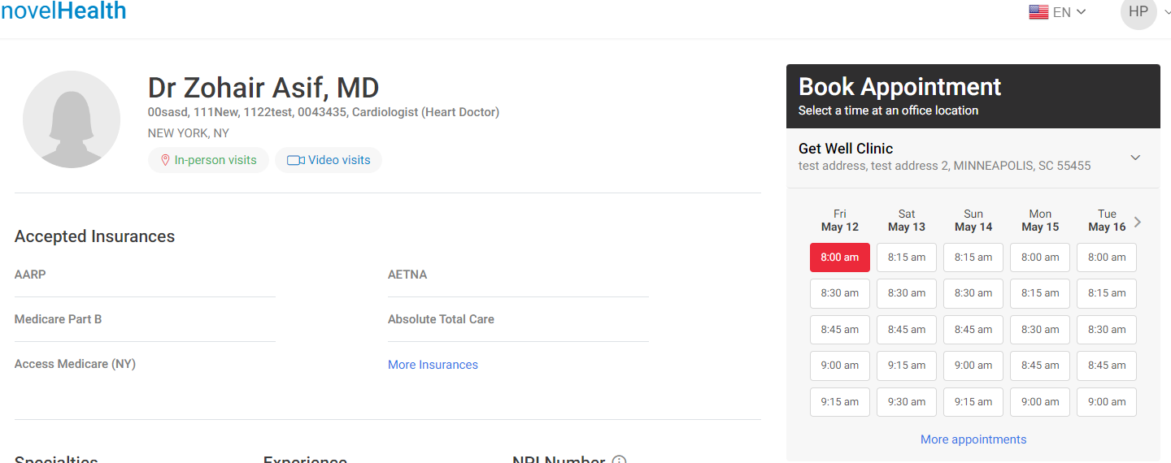

* Patient will land on appointment booking page. Select “**Video visit**" as visit type and press the "**Book Appointment**" button.

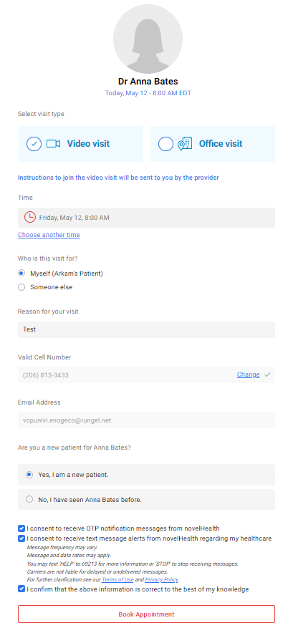

* On pressing the book appointment button from verification page, patient will land on Dashboard and TM appointment will get scheduled for the patient.

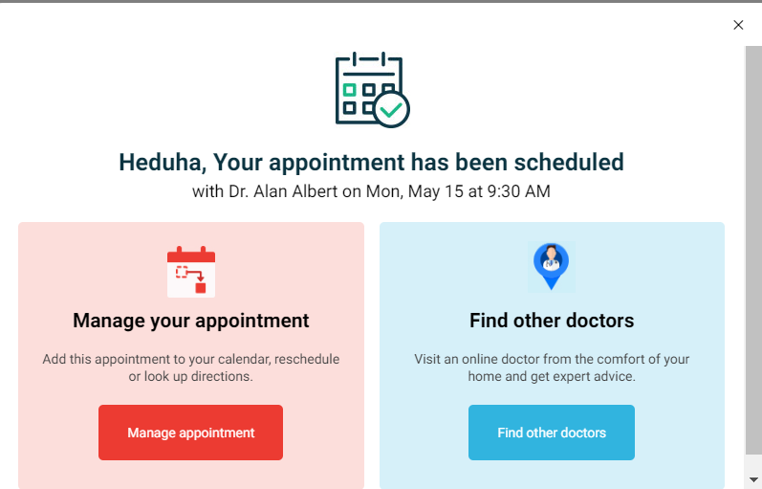

* Patient will receive TM Appointment confirmed email in his/her inbox.

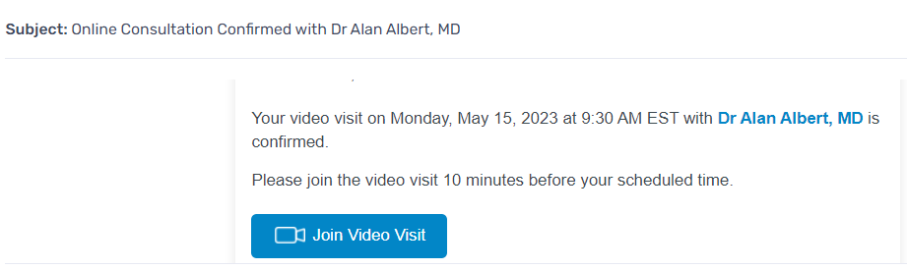

* The scheduled TM appointment will appear on patient’s dashboard.



* Patient can **Reschedule/Cancel** the appointment by selecting "**Modify**".

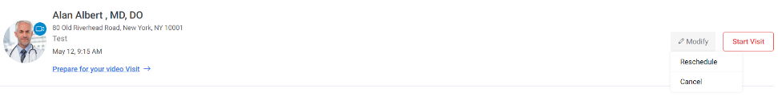

# Booking Office Visit / TM appointment as a non-vendor provider from Calendar Module

A non-vendor provider is the user that is only registered with novelHealth but not on CureMD 10G.

* To book the appointment from non-vendor, go to the URL <https://staging.novelhealth.ai/>.
* Login with valid credentials of non-vendor provider. User will land on the provider dashboard. ([james.watson@curemd.com](mailto:james.watson@curemd.com) / CMDSupport.2K&@)

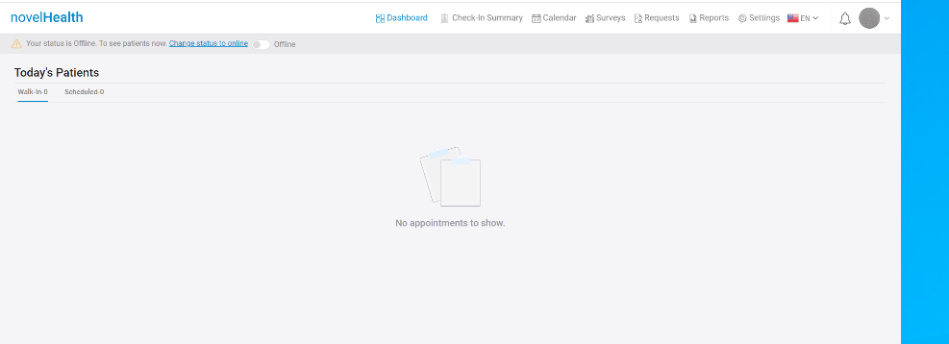

* Select the **Calendar** option from the top of the page.

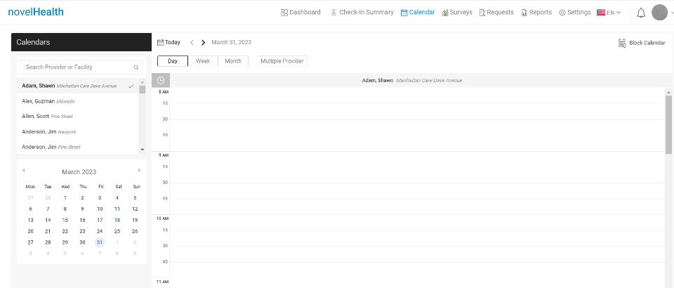

* Search and select the **Provider** from the search bar. Calendar will appear for the selected provider.

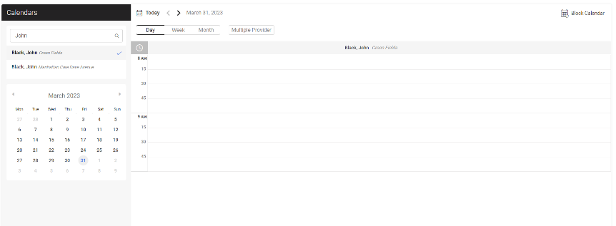

* Select available slot on the provider calendar. "**New Appointment**" screen will appear.

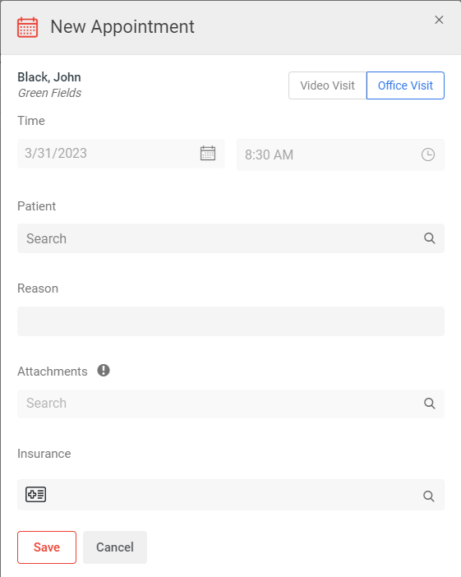

* Select **Patient**, appointment **Reason**, **Insurance** and press the save button.
  + For TM appointment select **Video Visit** as visit type.

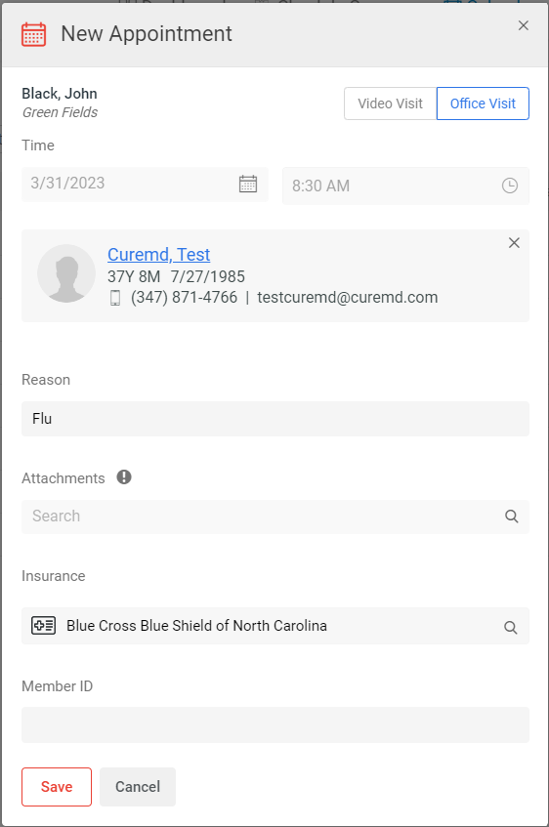

* Appointment will get scheduled for the patient.

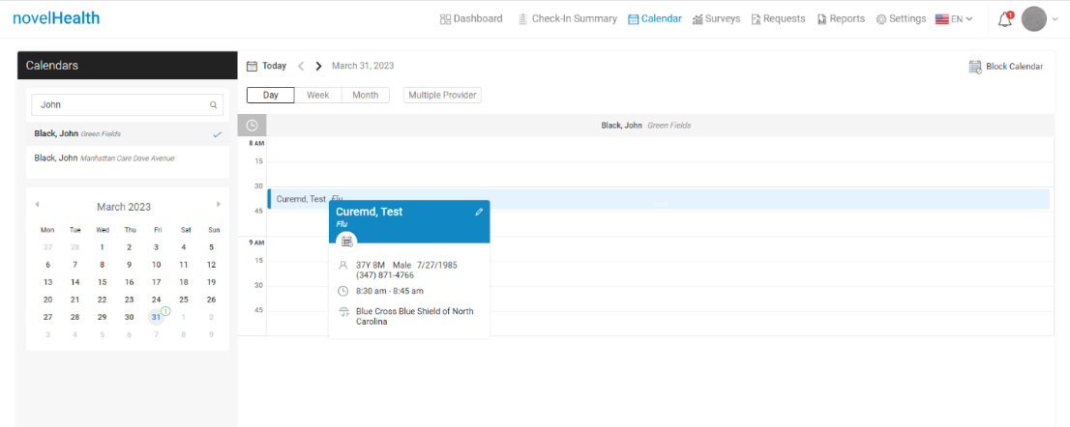

# Booking Office Visit / TM appointment as a Practice User from CureMD 10G

* To book the appointment as a practice user from CureMD 10g, go to the URL <https://releaseapp01.curemd.com/curemd/>. Credentials: zohair/ CMDSupport2P

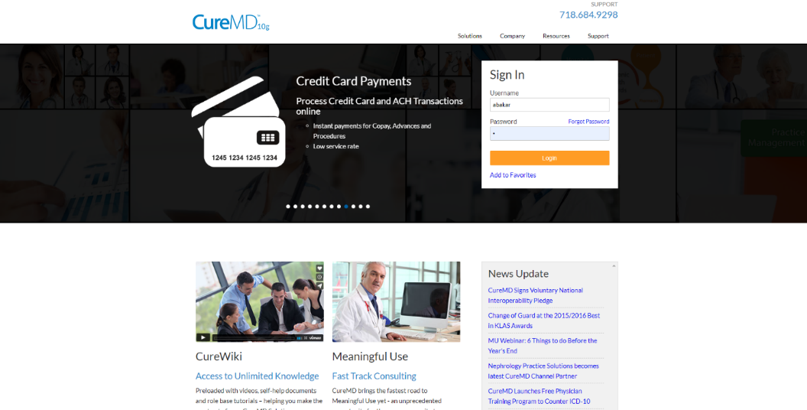

* Login with valid credentials of Practice User.

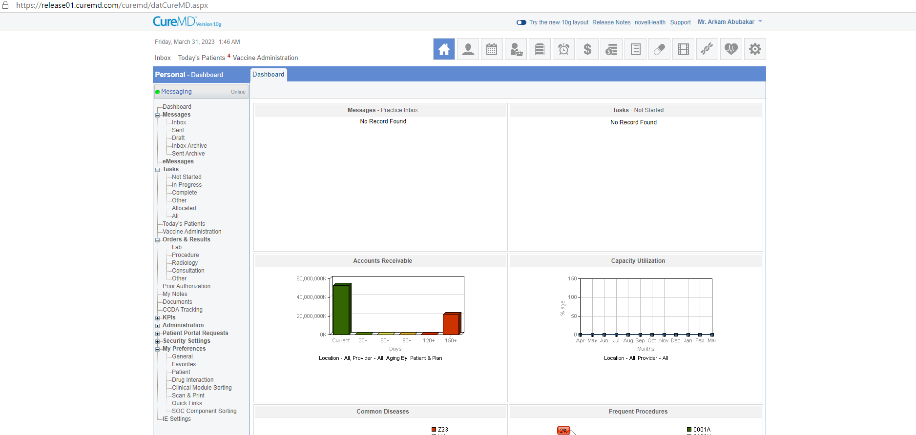

* Select the **Scheduler** from the top of the page. Select Practice **Location**, **Provider**, **Month** and **Date**. Calendar will appear for the selected provider and location.

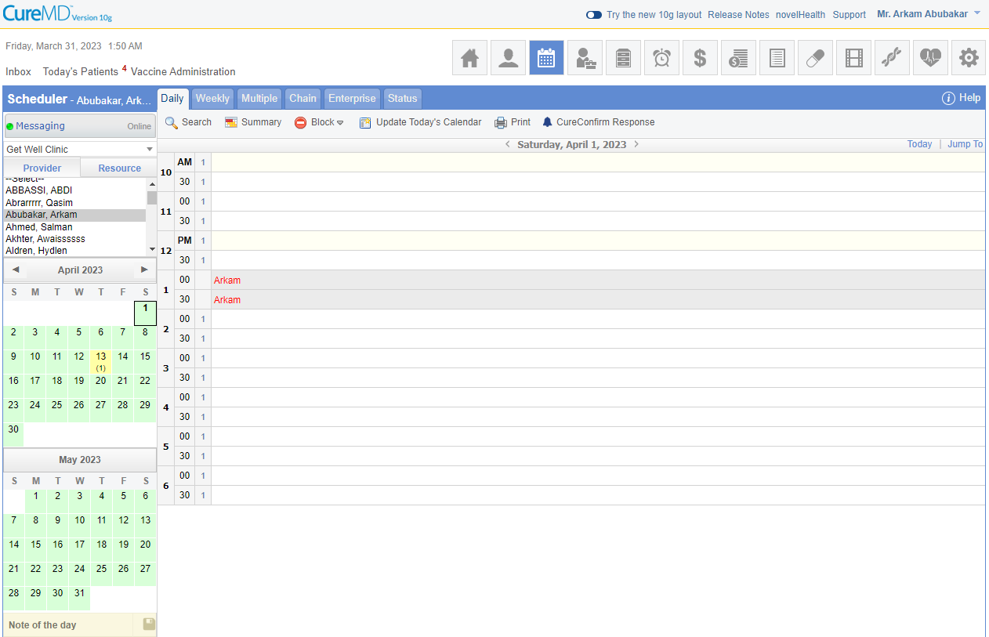

* Select slot on the provider calendar. "**Book Appointment**" screen will appear. Select patient from the **Hot List** of patients or **Search** patient. Provider can also add new patient from "**Quick Add**”.

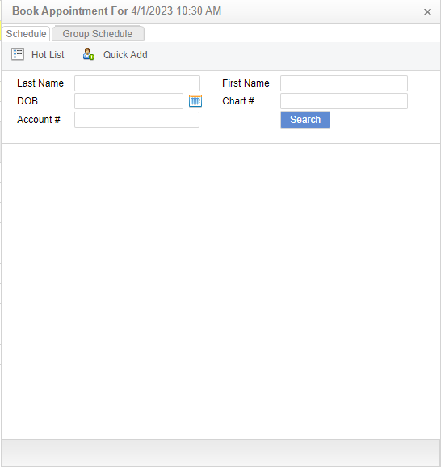

* Select appointment **Reason** and press the **Schedule** button.
  + From TM appointment, check **Telemedicine** bit.

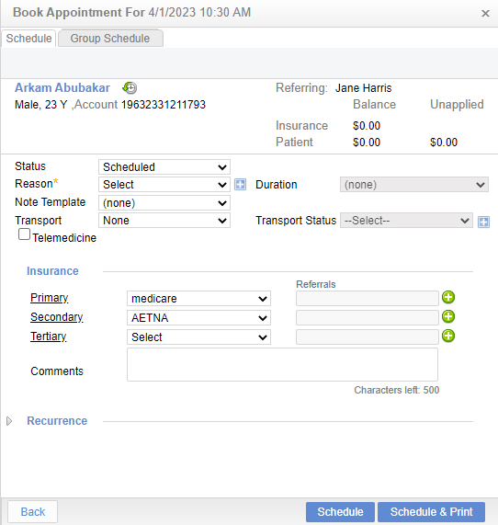

* Appointment will get scheduled for the patient.

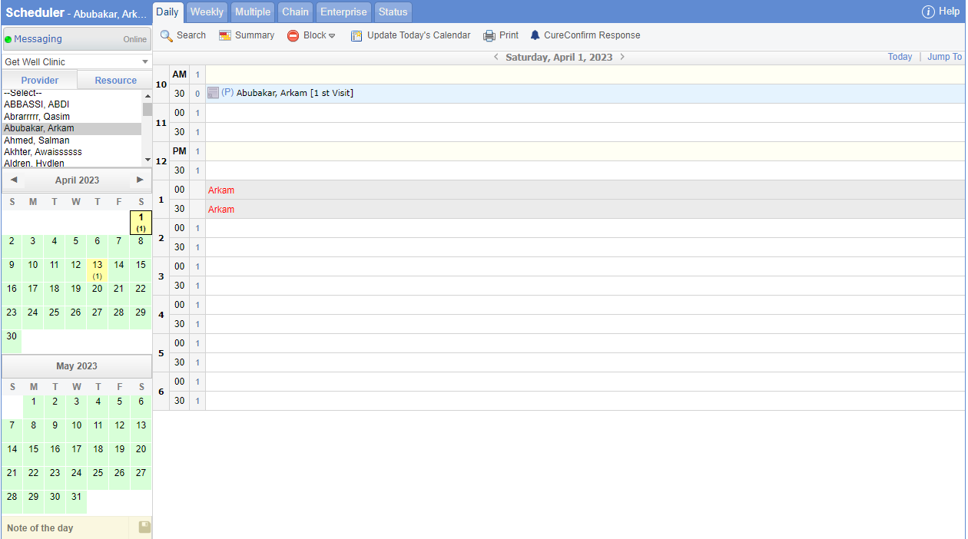

# Collect Patient Demographics at Booking/Enable Insurance/Enable Insurance Eligibility bits in appointment booking flow

* Go to the following URL <https://staging.novelhealth.ai/account>.
* Log into the NovelHealth application with valid credentials of provider. Take credentials from your TL/PM.
* Go to Settings>Users>Your User>Calendar>Edit Calendar>**Collect Patient Demographics at Booking**>Collect Patient Demographics on Televisit>**Enable Insurance**>**Enable Insurance Eligibility**>Enable Insurance Eligibility on Office Visit>Save.

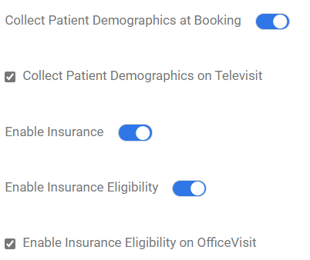

* Log into the NovelHealth application with valid credentials of patient.
* Book Office Visit / Video Visit appointment.

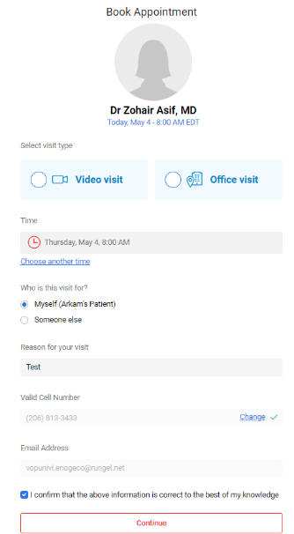

* On pressing the continue button from appointment booking screen, **Patient demographics** screen will appear.

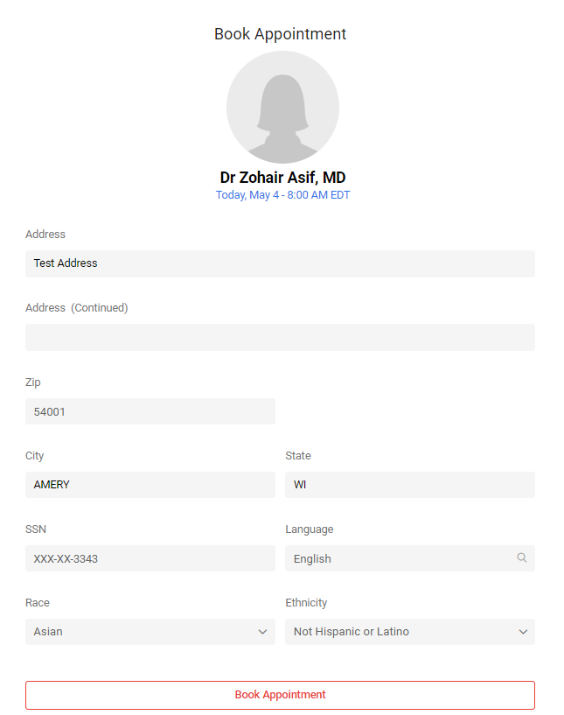

* On pressing the continue button from patient demographics screen, the Insurance Eligibility screen will appear.

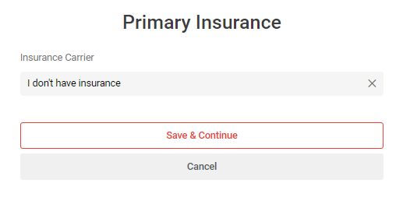

* Select valid **Insurance Carrier**, **Member Id**, **First Name**, **Last Name**, **DOB**. Press the next button. Insurance Eligibility will be verified for the patient.

